Get-Post-Put-Delete Method Procedure’s – Test Case’s

1)Get Method:

Call the Get program with URL as Input

As a Output – Get.Txt File will be created with all the details in the URL

2)Post Method:

Call the Post Method with Data to be posted

Response Header – With Success Message

Response Message with ID Created

Id – 1759 Created

End -Success Message Displayed

Post man Data:

3)Put Method:

Call the Put Method with Data to be Updated.

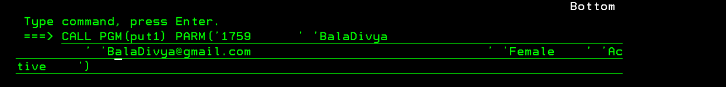

Response Header – With Success Message

Response Message:

Data Updated Successfully.

Post man Result:

4)Delete Method:

Call the Delete Method with ID to be Deleted.

Response Header – With Success Message

Response Message:

Data is Deleted.

\*\*\*END\*\*\*

Postman Results: